Currency Exchange

James LeBlanc

Operations

December 4, 2015

Table of Contents

Operations 2

Location and Layout 2

Supply Chain 3

Technology 3

Operation Budget 3

One-Time/Start-up Costs 4

Business Processes 4

Organization Chart 6

Operations Calendar 16

References 17

Appendix A 17

# Operations

## Location and Layout

The exchange will be located in Manhattan New York. The main office will be approximately 2,000 square feet and consist of the following:

* Reception area
* Offices for management personal
* Cubes for support personnel
* Secure data center
* Employee pantry
* Protected storage for on-site cash

## Supply Chain

NA – The exchange will deal directly with customers. All services will be provided via the company web portal or in person at the company office.

## Technology

* Internet
* Phone system
* Personal computers for employees
* Kiosk computers for customers
* Networking equipment
* Servers
* Proprietary software
* Email system

## Operation Budget

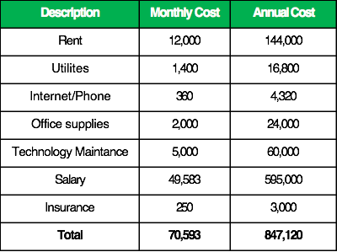

## One-Time/Start-up Costs

**Summary**

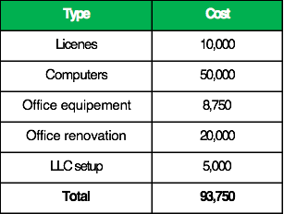

**Details**

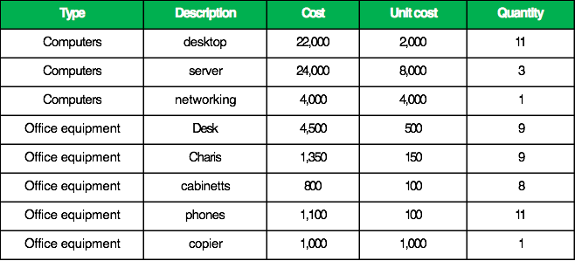

## Business Processes

Business processes will be grouped into the following categories. For further explanation see Appendix A.

*Hire Employee:* Hire employee processes will include all activities related the on boarding of a new employee. Included activities will be; develop job description, establish budget for salary, search for candidates, interview candidates, hire employee and setup new hire in HR system.

*Pay Employee:* Processes related to payroll

*Add new customer account:* Adding new users processes include; registering user in system, verifying customers identity, setting up two factor authentication, adding credit/debit account to customers profile.

*Deposit money:* Processes for handling all types of deposits such as; online credit / debit, in person cash deposits, wire transfers.

*Withdraw money:* Processes for handling all types of withdraws such as; online credit / debit, in person cash withdraws, wire transfers.

*Post Trade:* These processes relate to all trading activities including; retrieve order book status, retrieving trade history, posting bid / ask, completing buys and sells, assessing trade fees, canceling bid /ask.

*Customer Support:* Processes relating to customer service issues not covered by adding new customer processes such as; problems withdrawing funds, problems depositing funds, questions about web portal and user apps, help with web API.

*Marketing:* Processes relating to the creating and running of marketing campaigns. These include all process addressing customer acquisition and retention.

## Organization Chart

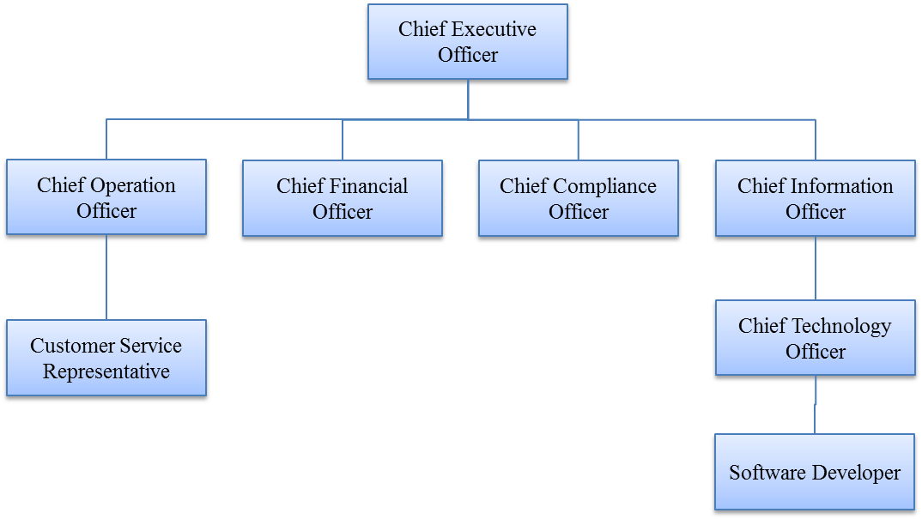

**Chief Financial Officer**

*Summary:* Responsible for overseeing and directing the organization's financial goals, objectives, and budgets. CFO will meet with the Board and other company executives to develop financial goals and budgets.

*Job Responsibilities:*

* Develop and implement and organization's financial goals.
* Oversee the investment of funds and manage associated risks.
* Supervise cash management activities.
* Execute capital-raising strategies to support a firm's expansion.
* Handle mergers and acquisitions.
* Act as financial gatekeeper.
* Supervise the preparation of the annual budget.
* Monitor and control accounts receivables.
* Prepare monthly financial statements, financial packages, and other informational reports/analysis.
* Develop and monitor policies and procedures within generally accepted accounting principles and corporate guidelines to ensure sufficient cash flow, reduced operating costs, and increased revenues.
* Improve profitability.
* Review prior financial results and discusses anticipated changes to highlight future needs and trends.
* Ensure underlying accounting records are accurate, complete and in accordance with GAAP.
* Review monthly operating reports for accuracy, completeness and major variances between actual and budget results.
* Approve monthly bank reconciliations.
* Prepare quarterly and annual fair value reports.
* Prepare summaries and forecasts for future business growth and general economic outlook.

*Annual Salary:* $75,000

*Education/Experience Required:* BA accounting or other financial discipline, 7 year financial / accounting experience.

*Personality Synopsis:* This person will be responsible to the financial health of the exchange. They must be organized, methodical and pay close attention to detail.

**Chief Information Officer**

*Summary:* Responsible for the technological direction of a company. Proposes budgets for programs and projects, purchases and upgrades equipment, supervises computer specialists and IT workers, and presides over IT-related projects.

*Job Responsibilities:*

* Provide technological guidance within an organization.
* Supervise information system and communications network.
* Develop and implement a customer service platform to serve the organization in every aspect.
* Design, establish, and maintain a network infrastructure for local and wide area connectivity and remote access.
* Consult with administration, department managers, and manufacturing representatives to exchange information, present new approaches, and to discuss equipment/system changes.
* Participate in vendor contract negotiations for all new computer equipment and software purchased for the corporation.
* Create a cost-benefit analysis as well as supporting a detailed definition of data requirements and departmental workflows.
* Oversee Internet and computer operations.
* Manages the day-to-day operations of the information technology department including directing staff, who support administrative computing, networking, user services, telecommunications and other information technology functions.
* Assess and anticipate technology projects and recommend appropriate action and resources.
* Establish and direct the strategic and tactical goals, policies, and procedures for the information technology department.
* Propose hardware/software solutions to accomplish the company's business objectives.
* Identify user needs and resolve problems.

*Annual Salary: $*75,000

*Education/Experience Required:* BA in Information System Management, 7 year experience as an IT professional. Background must include experience helpdesk and software development.

*Personality Synopsis:* This person must be will to wear many hats. As the leader of the IT the CIO must be forward thinking and always looking for ways to improve business processes.

**Chief Technology Officer**

*Summary:* Responsible for developing, enhancing, and deploying a company's web presence. CTO ensures execution of company's business goals and strategies.

*Job Responsibilities:*

* Establish governance processes of direction and control to ensure that objectives are achieved.
* Direct and development a security plan.
* Protect the confidentiality, integrity, and availability of the company’s data and servers.
* Identify and implement technology trends and platforms.
* Communicate the company’s technology strategy to investors, management, staff, partners, customers, and stakeholders.
* Evaluate and recommend technologies.
* Select and register company's domain names.
* Establish email service.
* Implement web-based internal communications system.
* Oversee graphic designer's efforts to create a company corporate identity and website.
* Manage vendor relationships.
* Conduct code reviews and specification conformance testing.
* Establish quality assurance process.
* Establish an application deployment process.
* Monitor web analytics regime to ascertain site traffic.
* Implement technical requirements for Internet marketing and search engine optimization.
* Integrate customer service and support with the software engineering process to support resolution of customer issues and improve application usability.

*Annual Salary:* $70,000

*Education/Experience Required:*  BA in Information System Management, 7 year experience working as a IT professional including experience implementing software solutions and managing software development efforts. Must also have experience in direct tech support.

*Personality Synopsis:* This person must enjoy the deployment and maintenance of IT systems. Must display a positive attitude and be ready to assist personal with all technology assistance.

**Chief Operation Officer**

*Summary:* Responsible for overseeing and guiding the day-to-day operations of a company. Presides over; revenue and sales growth, expense, cost and margin control, and monthly, quarterly and annual financial goal management.

*Job Responsibilities:*

* Develop and implement budgets.
* Direct company operations.
* Establish performance goals and barometers.
* Distribute resources.
* Develop, implement, and revise company policies as needed.
* Execute business strategies.
* Direct and participate in acquisition and growth activities to support overall business objectives and plans.
* Establish and monitor performance reporting system.
* Monitor department performance against performance goals to ensure that progress is being made.
* Oversee human resources department.
* Manage business relationships with key suppliers.
* Ensure products and services meet standards of quality and cost effectiveness.
* Perform quality control and order fulfillment duties.
* Manage internal systems and business processes.
* Develop new processes and programs.
* Inform the chief executive officer, and ultimately the board of directors, of all program issues and accomplishments.
* Assist the CEO in planning, organizing, and implementing public and private fund-raising initiatives

*Annual Salary:* $75,000

*Education/Experience Required:* BA in Business management, 5 year management experience.

*Personality Synopsis:* The COO must interact well with other people especially customers. Working well with others and demonstrated ability to motivate staff are requirements for this position.

**Chief Compliance Officer**

*Summary:* The Chief Compliance Officer oversees the companies Compliance Program, functioning as an independent and objective body that reviews and evaluates compliance issues/concerns within the organization. The position ensures the Board of Directors, management and employees are in compliance with the rules and regulations of regulatory agencies, that company policies and procedures are being followed, and that behavior in the organization meets the company’s Standards of Conduct.

*Job Responsibilities:*

* Develop, initiate, maintain, and revise policies and procedures for the general operation of the Compliance Program and its related activities to prevent illegal, unethical, or improper conduct. Manages day-to-day operation of the Program.
* Develops and periodically reviews and updates Standards of Conduct to ensure continuing currency and relevance in providing guidance to management and employees.
* Collaborates with other departments (e.g., Risk Management, Internal Audit, Employee Services, etc.) to direct compliance issues to appropriate existing channels for investigation and resolution. Consults with the Company attorneys as needed to resolve difficult legal compliance issues.
* Responds to alleged violations of rules, regulations, policies, procedures, and Standards of Conduct by evaluating or recommending the initiation of investigative procedures. Develops and oversees a system for uniform handling of such violations.
* Acts as an independent review and evaluation body to ensure that compliance Issues/concerns within the organization are being appropriately evaluated, investigated and resolved.
* Monitors, and as necessary, coordinates compliance activities of other departments to remain abreast of the status of all compliance activities and to identify trends.
* Identifies potential areas of compliance vulnerability and risk; develops/implements corrective action plans for resolution of problematic issues, and provides general guidance on how to avoid or deal with similar situations in the future.
* Provides reports on a regular basis, and as directed or requested, to keep the Corporate Compliance Committee of the Board and senior management informed of the operation and progress of compliance efforts.
* Ensures proper reporting of violations or potential violations to duly authorized enforcement agencies as appropriate and/or required.
* Establishes and provides direction and management of the compliance Hotline.
* Institutes and maintains an effective compliance communication program for the organization, including promoting (a) use of the Compliance Hotline; (b) heightened awareness of Standards of Conduct, and (c) understanding of new and existing compliance issues and related policies and procedures.
* Works with the Human Resources Department and others as appropriate to develop an effective compliance training program, including appropriate introductory training for new employees as well as ongoing training for all employees and managers.
* Monitors the performance of the Compliance Program and relates activities on a continuing basis, taking appropriate steps to improve its effectiveness.

*Annual Salary:* $75,000

*Education/Experience Required:* A Legal degree plus 7 years’ experience working in compliance.

*Personality Synopsis:* The compliance officer is the watch dog of the organization. He/she must be able to enforce company and regulator policies. The COO must not be afraid of confrontation or difficult situations.

**Customer Service representative**

*Summary:* The position is the face of the company and will interact directly with customers.

*Job Responsibilities:*

* Answer phone and address customers issues
* Handle cash deposits and withdraws
* Register customers

*Annual Salary:* $50,000

*Education/Experience Required:* Associate degree. With 1 year customer service experience

*Personality Synopsis:* Must have a sunny personality and be will to work directly with the public. Must be patient and understand and above all friendly and professional.

**Software Developer**

*Summary:* The position will be responsible for the design and development of the exchange software.

*Job Responsibilities:*

* Design and develop software
* Debug and patch existing software
* Research new technologies and framework that will benefit the exchange

*Annual Salary:* $50,000

*Education/Experience Required:* Associate degree. With 3 software development experience

*Personality Synopsis:* The person must be able to work independently. He/she must be detail oriented and demonstrate good time management. He/she must be able to work on multiple projects simultaneously.

**Start-up personal**



**End of year 1:** If revenue projections hold by then end of year 1 we will add 2 additional developers and one additional customer service representative bring the total developers to three and customer service reps to two.

**End of year 2:** If revenue projections for year two hold will add additional developers and customer service representatives as needed.

## Operations calendar

**September 2016:** Hire CFO, CIO, CCO

**December 2016:** Build prototype of exchange software, setup development server.

**June 2016:** Obtain required licenses and permits.

**July 2016:** Hire CTO and developer.

**July 2017:** Build production datacenter and exchange software

**August 2017:** Hire COO and customer service rep

**September 2017:** Launch exchange

**October 2017:** First promotional effort

# References

# Appendix A